**Commodore VIC-20: Super Expander II Rev. 1**

**Testing**

# Test Setup

The tests were conducted with a VickyTwenty (Reproduction of ASSY 250403 Rev. D) and a Super Expander II cartridge (Rev. 1) with 3k of RAM (6 pcs of National Semiconductor MM2114N) and up to two (ST) 27C512 EPROMs (120ns).

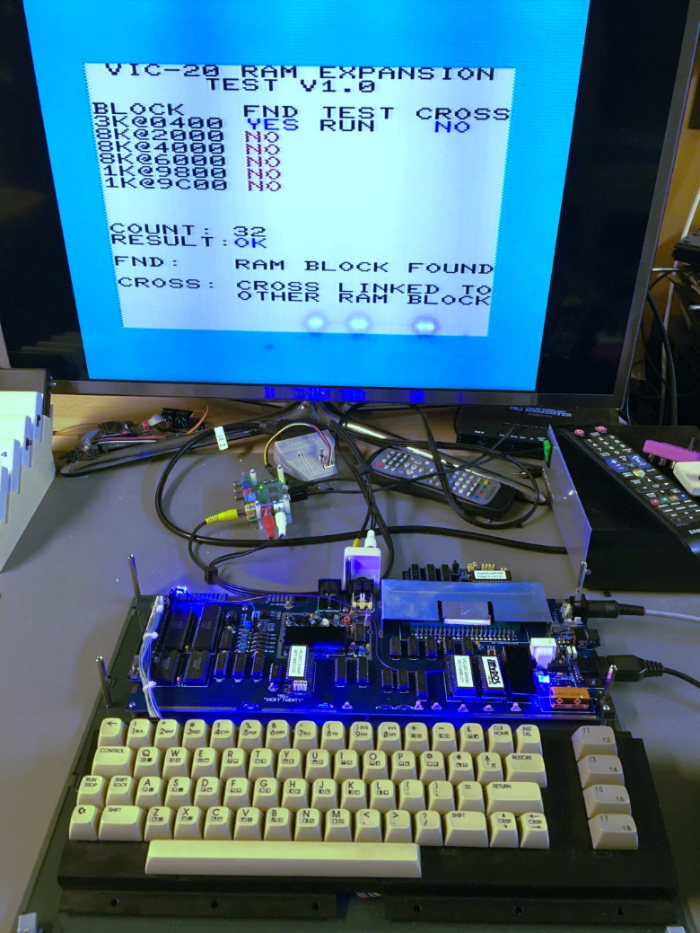

Figure 1: Test Setup

# Test Execution

## Super Expander Software

First, the original Super Expander Software from zimmers.net and the Commodore VICMON for $B000 were programed to an EPROM. These two programs fit into one 8k memory bank, since the Super Expander software is a 4k software. The EPROM was inserted the in IC1 socket and (JP1) was set to ($A000-$BFFF). The software size of 8k (for IC1) was set on JP4.

The cartridge was inserted into the VickyTwenty and the computer was switched on. It booted normally and 6519 Bytes Free were reported. The Super Expander requires bytes in RAM, so this is correct.

The function keys produce some of the additional Super Expander instructions. A short program, which is using those instructions, was executed successfully.

* **Function of RAM and EPROM IC1 with and the Super Expander Software verified.**

SYS11*4096 (which is $B000) started the VICMON.

* **Additional test.**

The software size was configured to 4k (JP4). So, the VICMON was not visible anymore. The VIC-20 booted properly.

SYS11*4096 resulted in a software crash, which shows that the software size selection is working.

* **Software size selection (4k/8k) for IC1 is working properly.**

## RESET Button

The RESET button (SW1) was pressed. The VIC-20 rebooted properly.

* **RESET button verified**

## RAM Expansion Test software

The jumpers on JP3 were set to the 2nd 8k (A15..13: set/set/open), JP1 remained at .  
The software was executed properly. The 3k RAM expansion was found. Over 10,000 test cycles were carried out properly.

* **The bank selection on JP3 (001) works properly**
* **RAM works properly**

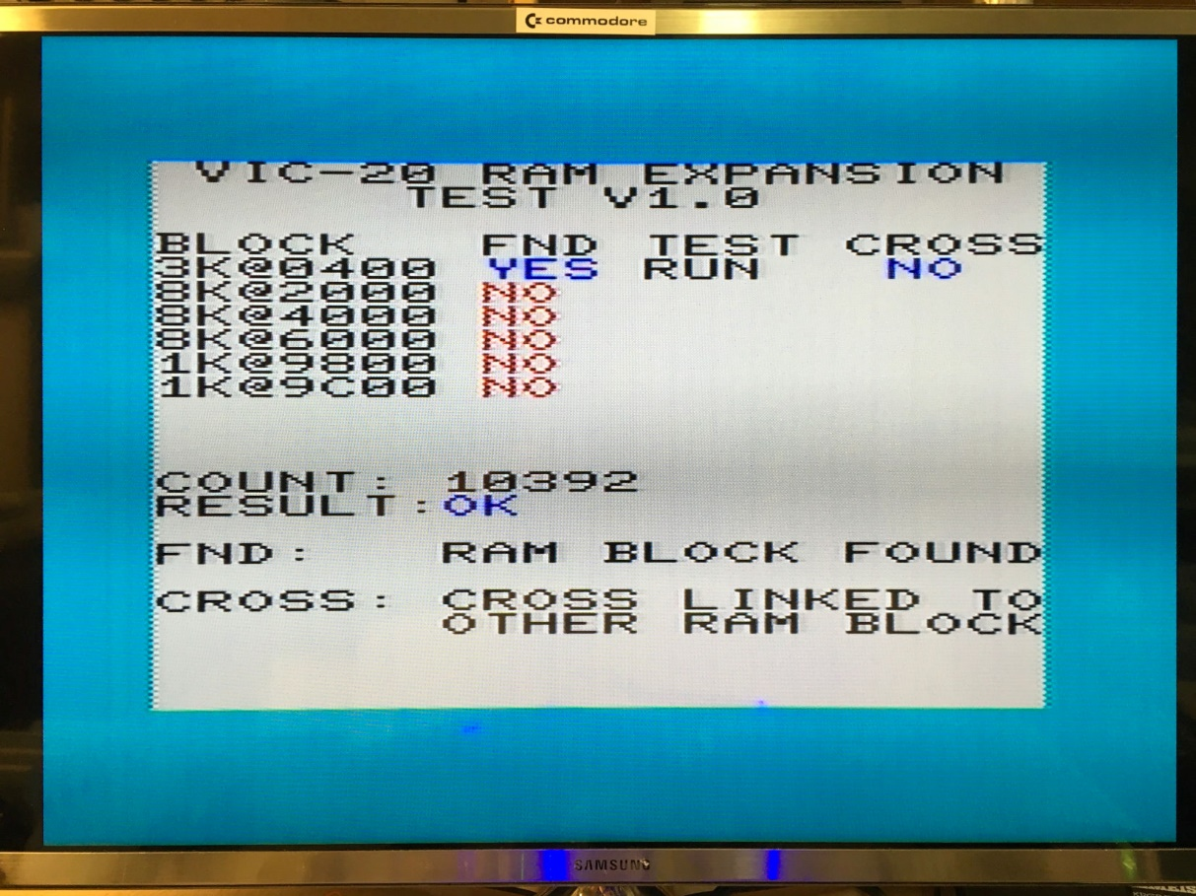

Figure 2: 3k RAM Expansion Test

## VIC-20 Diagnostic Software

The software (PAL) also origins from zimmers.net. It was programmed into the 2nd 8k of the said EPROM, a different version of this software (NTSC) was programmed to the 3rd 8k.

The jumpers on JP3 were set to the 3rd 8k (A15..13: set/open/set), JP1 remained at .

The diagnostics software started and executed properly (together with the VIC-20 diagnostics harness). For the 2nd version of the diagnostic software, JP3 was set to the 3rd 8k bank (A15..13: set/open/open). This software executed properly, too.

* **Bank select (000, 001, 010, 011) on JP3 verified**

## Game Cartridge Donkey Kong

This game is a 16k game and requires both EPROMs.  
The software for $A000 was programmed in a fresh EPROM, which was inserted into IC1. JP1 remained at . The other part of the software, which is located at $2000 was programmed into another fresh EPROM, which was then inserted into the IC2 socket. JP2 was set to . All jumpers on JP3 were set.

The software started properly and the game could be played.

* **EPROM IC2 with verified**

## Game Cartridge AE

The software origins from zimmers.net. It consisted of two images, one for $A000 and one for $6000. The images were programmed into two EPROMs, the $A000 software was inserted into IC1, the $6000 software into IC2. Jumper JP1 was set to , JP2 to . The software started properly and the game could be played. The software size (JP4 and JP5) was set to 8k.

* **EPROM IC2 with verified**

## VIC-MON (for $4000)

The source of this software is once again zimmers.net. It was programmed into the 5th 8k memory bank (@ buffer address $8000) of an EPROM. The EPROM was inserted into IC1 and JP1 was set to .

SYS4x4096 started the software properly.

* **Bank select (100) on JP3 and (JP1) verified**

## Installation in cartridge cases

The fully assembled Super Expander II PCB (all ICs on sockets and all vertical jumpers) was installed in the **original Commodore Super Expander cartridge case**- This could be accomplished without a problem.

The **original Commodore Game cartridge case** required removing some support structures for small PCBs, after that, it also fit.

The **tfw8bit.com VIC-20 cartridge case** fits after removing the support structures for the short PCBs.

* **Dimensions verified**

# Conclusion

**The Super Expander II Rev. 1 is fully functional**